Day 5 – Retail Inventory Management
Name: Harini M M

1. The original spreadsheet (UNF)
A few sample rows from the spreadsheet:
SKU | Product | Category | Supplier | Supplier Phone | Warehouse | Qty | Reorder Level
SKU1003 | Potato Chips 100g | Snacks | Kovai Fresh Foods | 9876543202 | Coimbatore Main WH | 200 | 50
SKU1003 | Potato Chips 100g | Snacks | Kovai Fresh Foods | 9876543202 | Salem Hub | 15 | 50
SKU1010 | Frozen Peas 500g | Frozen Foods | Kovai Fresh Foods | 9876543202 | Coimbatore Main WH | 0 | 25
SKU1005 | Bath Soap | Personal Care | Lakshmi Agencies | 9876543204 | Trichy Depot | 150 | 60
From these records, I observed that supplier details and product information are repeated for different warehouse entries.

Anomalies in the original sheet
Insert anomaly: An insert anomaly occurs when I cannot add supplier or warehouse details independently without entering a product record. For example, a new warehouse that has no stock yet cannot be saved on its own.
Update anomaly: If Kovai Fresh Foods changes its phone number, I have to change it in every row where it appears. If I miss even one row, the same supplier ends up with two different phone numbers.
Delete anomaly: If SKU1005 (Bath Soap) is the only product from Lakshmi Agencies and I delete that row because the product is discontinued, I also lose the supplier's name and phone number forever.

Normalisation step by step

1NF (First Normal Form)
Rule: every cell must hold only one value (atomic), and there should be no repeating groups of columns.
A bad row would look like this, where one product is stored in two warehouses in the same cell:
SKU | Product | Warehouse | Qty
SKU1003 | Potato Chips 100g | Coimbatore Main WH, Salem Hub | 200, 15
To fix it, I make one row for each product and warehouse combination:
SKU | Product | Warehouse | Qty
SKU1003 | Potato Chips 100g | Coimbatore Main WH | 200
SKU1003 | Potato Chips 100g | Salem Hub | 15
I separated the warehouse entries so that each row contains only one warehouse and its corresponding quantity. This satisfies the 1NF condition.

2NF (Second Normal Form)
Rule: the table must be in 1NF and there should be no partial dependency, which means no column should depend on only a part of the composite key.
Our key is (SKU, Warehouse). Look at what each column depends on:
- Quantity depends on both SKU and Warehouse (stock of that product in that warehouse). This is fine.
- Product name, category, supplier, supplier phone and reorder level depend only on SKU. This is a partial dependency, so it breaks 2NF.
- Warehouse details depend only on Warehouse.
Fix: split into separate tables.
- products (SKU, product name, category, supplier, supplier phone, reorder level)
- warehouses (warehouse)
- stock (SKU, warehouse, quantity)

3NF (Third Normal Form)
Rule: the table must be in 2NF and there should be no transitive dependency, which means a non-key column should not depend on another non-key column.
In the products table: SKU → supplier name → supplier phone. The phone number does not depend on the SKU directly, it depends on the supplier. That is a transitive dependency. The same thing happens with the category name.
Fix: move supplier details and category details into their own tables, and keep only their IDs in products.
After separating supplier and category details, the tables have fewer repeated values. Each non-key column depends on its table's primary key, which satisfies 3NF.

3. Final design (minimum tables)
I ended up with 5 tables. I tried not to add anything extra.
Table | Primary key | What it stores
categories | category_id | category names
suppliers | supplier_id | supplier name and phone
warehouses | warehouse_id | warehouse name and city
products | product_id (SKU is UNIQUE) | product details, reorder level, status
stock | stock_id | quantity of a product in a warehouse
Assumptions I made: the reorder level is decided per product (not per warehouse), and one product has one supplier. I also added a status column (ACTIVE or DISCONTINUED) in products, because Task 4 needs a way to find discontinued SKUs.

Relationships
- One category has many products (1 : M)
- One supplier supplies many products (1 : M)
- One product can be stored in many warehouses, and one warehouse holds many products. This is M : N, so the stock table sits in the middle and splits it into two 1 : M relationships.

ER diagram
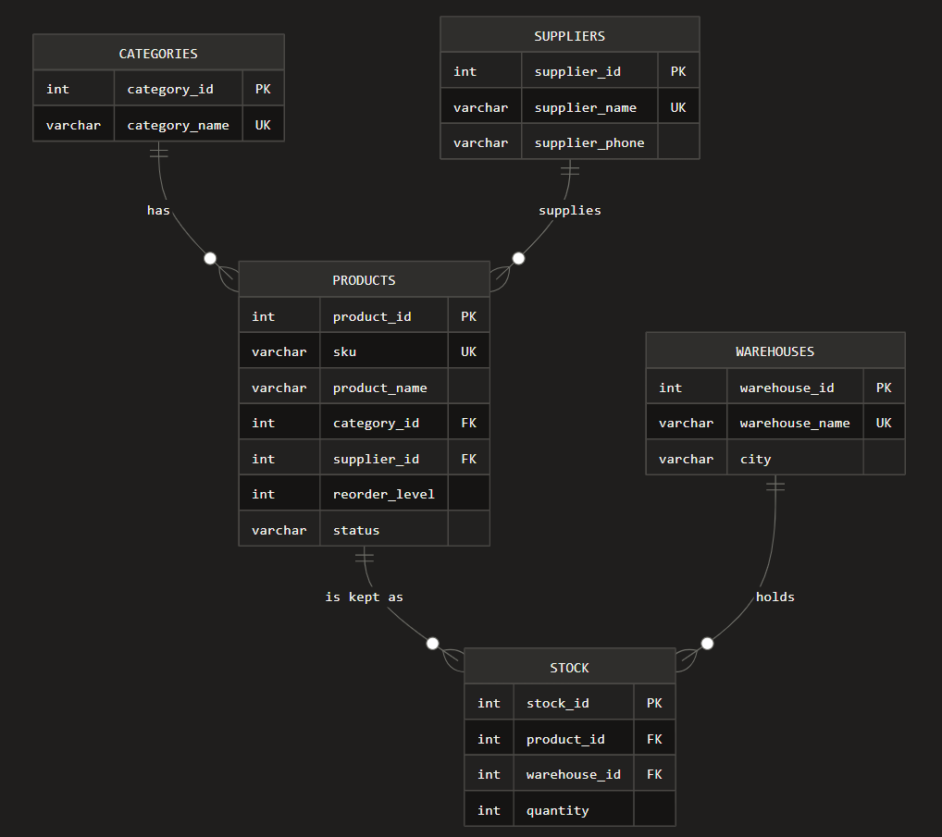
PK = primary key, FK = foreign key. products.category_id and products.supplier_id are FKs, and stock.product_id and stock.warehouse_id are FKs.

4. schema.sql (DDL)
The complete script is in schema.sql. It drops and recreates the database retail_inventory, then creates the tables in this order: categories, suppliers, warehouses, products, stock. Parent tables must come first, otherwise the foreign keys fail.
The two main tables:
CREATE TABLE products (
product_id INT NOT NULL AUTO_INCREMENT,
sku VARCHAR(20) NOT NULL,
product_name VARCHAR(100) NOT NULL,
category_id INT NOT NULL,
supplier_id INT NOT NULL,
reorder_level INT NOT NULL DEFAULT 10,
status VARCHAR(15) NOT NULL DEFAULT 'ACTIVE',
PRIMARY KEY (product_id),
CONSTRAINT uq_products_sku UNIQUE (sku),
CONSTRAINT chk_products_reorder CHECK (reorder_level >= 0),
CONSTRAINT chk_products_status CHECK (status IN ('ACTIVE', 'DISCONTINUED')),
CONSTRAINT fk_products_category FOREIGN KEY (category_id)
REFERENCES categories (category_id)
ON DELETE RESTRICT ON UPDATE CASCADE,
CONSTRAINT fk_products_supplier FOREIGN KEY (supplier_id)
REFERENCES suppliers (supplier_id)
ON DELETE RESTRICT ON UPDATE CASCADE
) ENGINE=InnoDB;
CREATE TABLE stock (
stock_id INT NOT NULL AUTO_INCREMENT,
product_id INT NOT NULL,
warehouse_id INT NOT NULL,
quantity INT NOT NULL DEFAULT 0,
PRIMARY KEY (stock_id),
CONSTRAINT uq_stock_product_warehouse UNIQUE (product_id, warehouse_id),
CONSTRAINT chk_stock_quantity CHECK (quantity >= 0),
CONSTRAINT fk_stock_product FOREIGN KEY (product_id)
REFERENCES products (product_id)
ON DELETE RESTRICT ON UPDATE CASCADE,
CONSTRAINT fk_stock_warehouse FOREIGN KEY (warehouse_id)
REFERENCES warehouses (warehouse_id)
ON DELETE RESTRICT ON UPDATE CASCADE
) ENGINE=InnoDB;

Where each requirement is used
Requirement | Where
InnoDB | every table has ENGINE=InnoDB
Primary key | the _id column of every table
Foreign key | products (2 FKs), stock (2 FKs)
UNIQUE | category_name, supplier_name, warehouse_name, sku, and (product_id, warehouse_id) in stock
CHECK | quantity >= 0, reorder_level >= 0, status IN (...)
DEFAULT | quantity 0, reorder_level 10, status 'ACTIVE', city 'Coimbatore'
ON DELETE RESTRICT | a parent row cannot be deleted while child rows exist
ON UPDATE CASCADE | if a parent ID changes, the child rows change automatically

5. seed_data.sql (sample data)
The file seed_data.sql inserts the rows in parent-first order. Row counts after seeding:
Table | Rows
categories | 10
suppliers | 10
warehouses | 10
products | 12 (10 ACTIVE + 2 DISCONTINUED)
stock | 14
The two discontinued products (SKU1011 and SKU1012) have no stock rows on purpose, so they can be deleted in Task 4 without breaking the RESTRICT rule.

6. Four failing INSERTs
These are in seed_data.sql as commented lines. Run them one at a time (Workbench or the mysql prompt) and take a screenshot of each error as evidence.
1. Duplicate key (SKU1001 already exists):
INSERT INTO products (sku, product_name, category_id, supplier_id, reorder_level)
VALUES ('SKU1001', 'Brown Rice 1kg', 1, 3, 15);
Expected: ERROR 1062 (23000): Duplicate entry 'SKU1001' for key 'products.uq_products_sku'
2. Missing parent (category 99 does not exist):
INSERT INTO products (sku, product_name, category_id, supplier_id)
VALUES ('SKU1013', 'Green Tea Box', 99, 1);
Expected: ERROR 1452 (23000): Cannot add or update a child row: a foreign key constraint fails (retail_inventory.products, CONSTRAINT fk_products_category FOREIGN KEY (category_id) REFERENCES categories (category_id) ON UPDATE CASCADE)
3. Negative quantity (CHECK fails):
INSERT INTO stock (product_id, warehouse_id, quantity)
VALUES (3, 5, -10);
Expected: ERROR 3819 (HY000): Check constraint 'chk_stock_quantity' is violated.
4. NULL in a mandatory column:
INSERT INTO products (sku, product_name, category_id, supplier_id)
VALUES ('SKU1014', NULL, 1, 1);
Expected: ERROR 1048 (23000): Column 'product_name' cannot be null
Bonus (shows ON DELETE RESTRICT):
DELETE FROM categories WHERE category_id = 1;
Expected: ERROR 1451 (23000): Cannot delete or update a parent row: a foreign key constraint fails (...), because Groceries still has products.
Evidence: paste your screenshots of the four errors here.

7. UPDATE and DELETE with SELECT before and after

Correcting a supplier phone number
-- before
SELECT supplier_id, supplier_name, supplier_phone FROM suppliers WHERE supplier_id = 2;
UPDATE suppliers SET supplier_phone = '9876543299' WHERE supplier_id = 2;
-- after
SELECT supplier_id, supplier_name, supplier_phone FROM suppliers WHERE supplier_id = 2;
Before: Kovai Fresh Foods has 9876543202. After: 9876543299. Since the phone is stored only once (thanks to 3NF), one UPDATE fixes it for all its products. In the original spreadsheet I would have needed to edit many rows.

Removing discontinued SKUs
-- before
SELECT product_id, sku, product_name, status FROM products WHERE status = 'DISCONTINUED';
DELETE FROM products WHERE status = 'DISCONTINUED';
-- after
SELECT product_id, sku, product_name, status FROM products WHERE status = 'DISCONTINUED';
SELECT COUNT(*) AS total_products FROM products;
Before: 2 rows (SKU1011 and SKU1012). After: empty set, and the product count goes from 12 to 10. I always write the WHERE clause, because DELETE without WHERE removes the whole table.
If a discontinued product still had rows in stock, the DELETE would fail with error 1451. In that case I must delete its stock rows first.

8. The four MySQL system databases
Run SHOW DATABASES; and you will see these four along with my own database.
Database | What it is (in simple words)
information_schema | A read-only "directory" of the server. It has details about all databases, tables, columns, constraints and engines. The tables inside are views, not real stored data.
mysql | The core database of the server. It stores user accounts, passwords, privileges and other internal system tables. I should never edit it by hand.
performance_schema | Used for monitoring. It collects live information about how the server is running, such as waits, running statements and memory use.
sys | A helper database made of easy-to-read views and procedures built on top of performance_schema and information_schema, so a DBA does not have to write complex queries.

9. Listing tables, engines and row counts from information_schema
SELECT table_name AS table_name,
engine AS engine,
table_rows AS approx_rows
FROM information_schema.tables
WHERE table_schema = 'retail_inventory'
ORDER BY table_name;
Important point for InnoDB: table_rows is only an estimate, so it can show a slightly wrong number. To get a correct number I can refresh the statistics first:
SET SESSION information_schema_stats_expiry = 0;
ANALYZE TABLE categories, suppliers, warehouses, products, stock;
or just use COUNT(*) as a cross-check (this is also in the seed file):
SELECT 'categories' AS table_name, COUNT(*) AS exact_rows FROM categories
UNION ALL SELECT 'suppliers', COUNT(*) FROM suppliers
UNION ALL SELECT 'warehouses', COUNT(*) FROM warehouses
UNION ALL SELECT 'products', COUNT(*) FROM products
UNION ALL SELECT 'stock', COUNT(*) FROM stock;
Expected after the DELETE in section 8: categories 10, suppliers 10, warehouses 10, products 10, stock 14. The engine column shows InnoDB for all five tables.

